Case Study 3 — Real-Time Data Lakehouse Architecture

By Kafeel Kamran

Data: hw_200.csv,

Sales.csv (https://www.kaggle.com/datasets/karkavelrajaj/amazon-sales-dataset )

Docs for reference

Basic Environment setup (Nifi + Kafka)

* ***Start and run zookeeper***

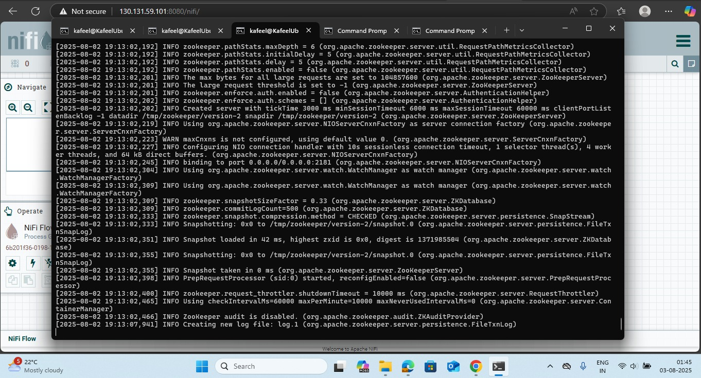

* ***Start and run Kafka server***

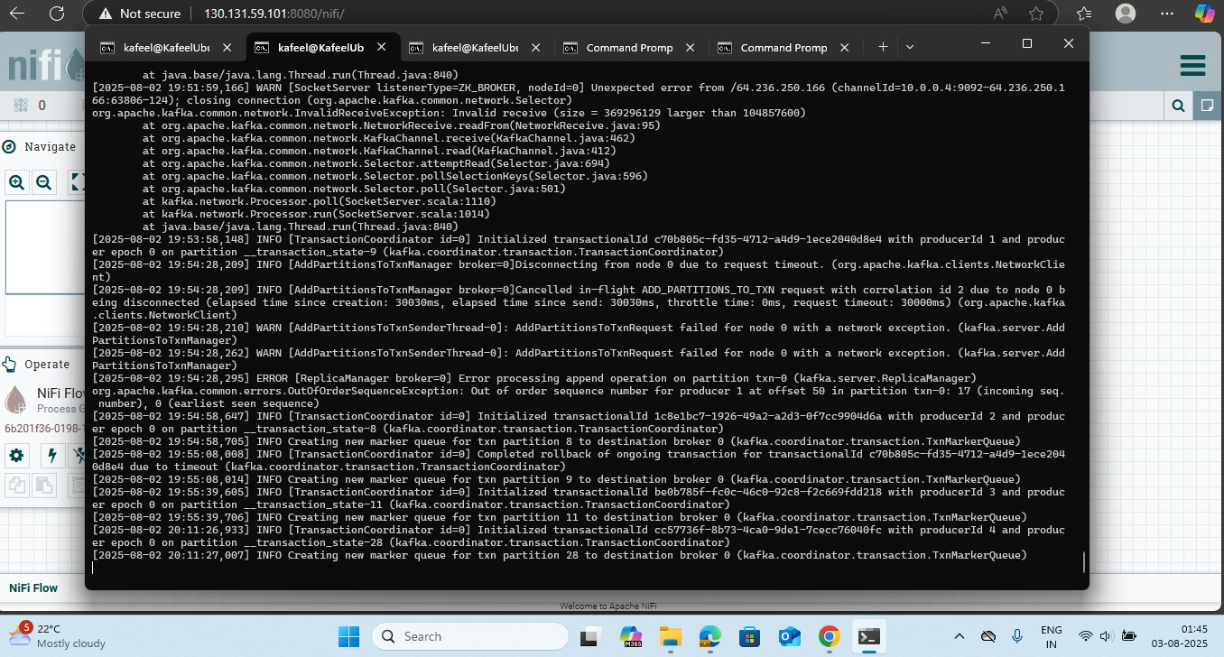

* ***Create a topic ‘txn’ from VM***

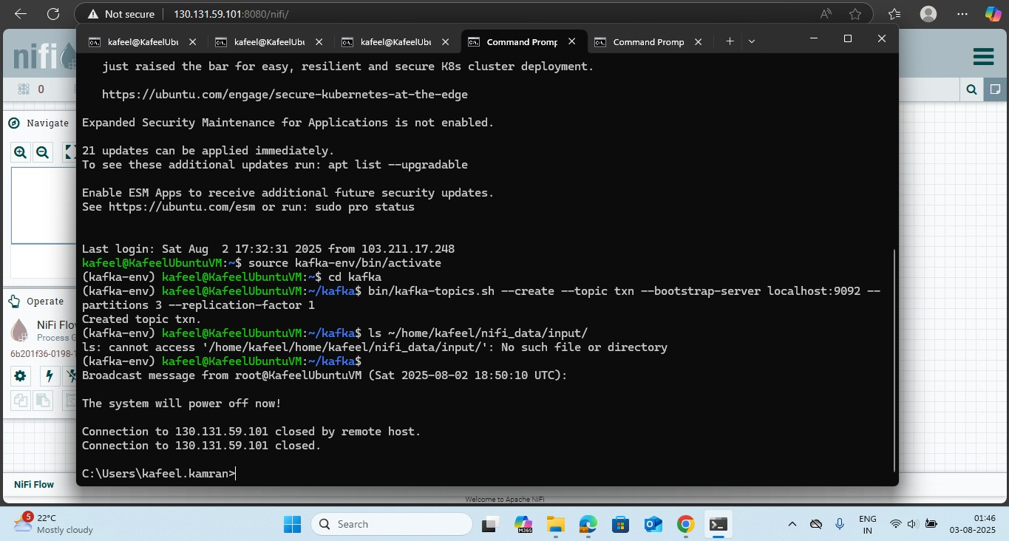

* ***Configure and run Nifi***

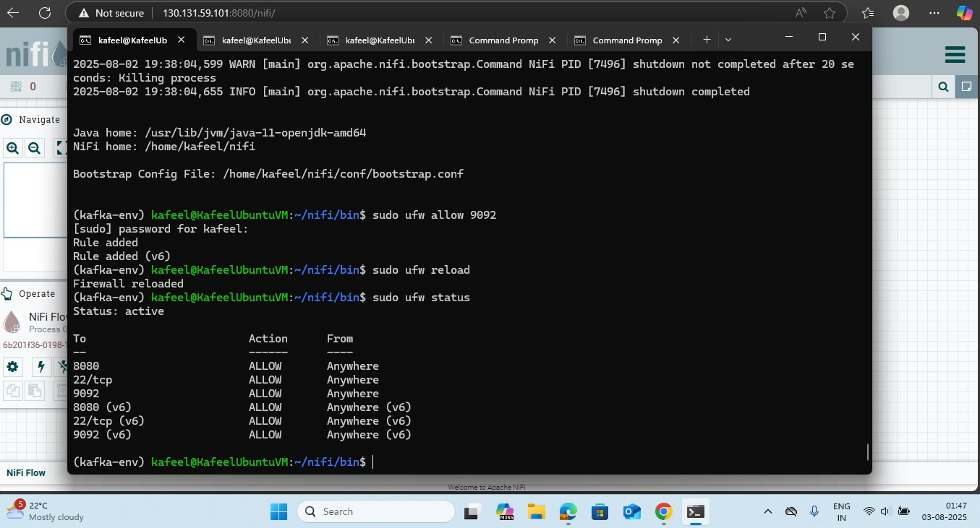

* ***KafkaPublish_2.0 Config***

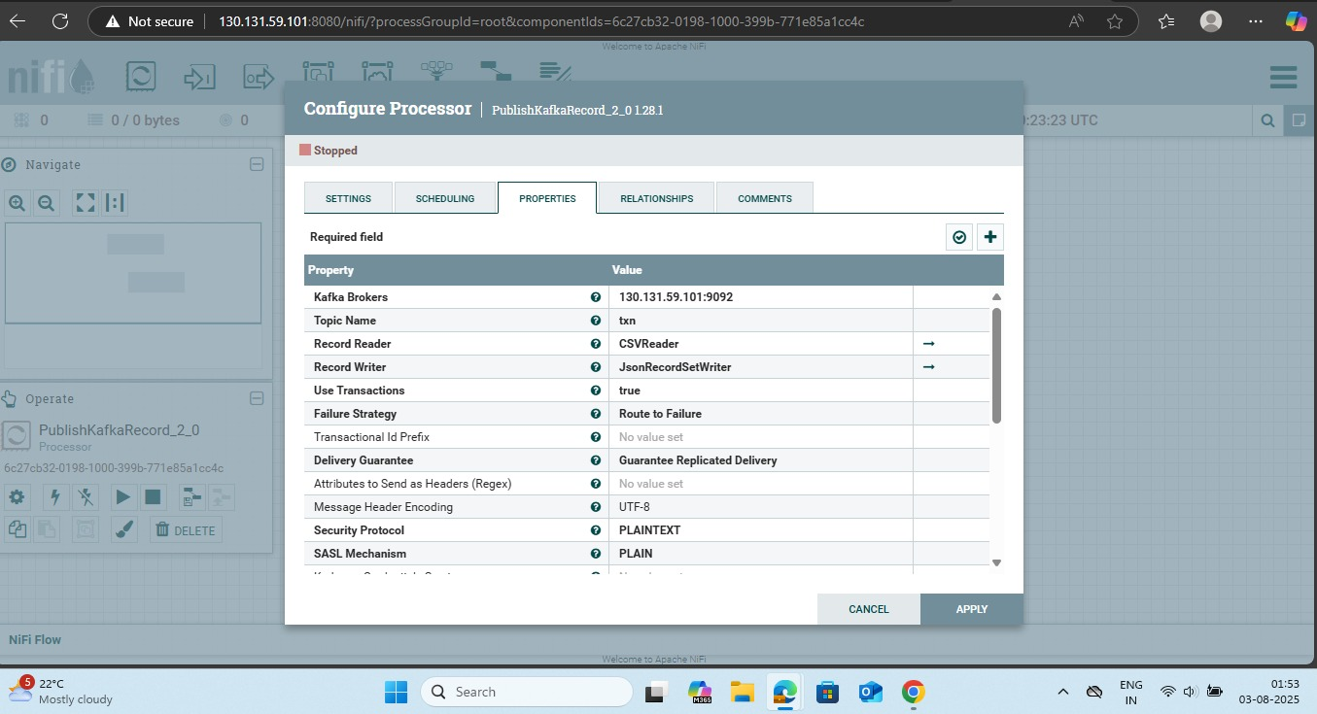

* ***Getfile (input dir config)***

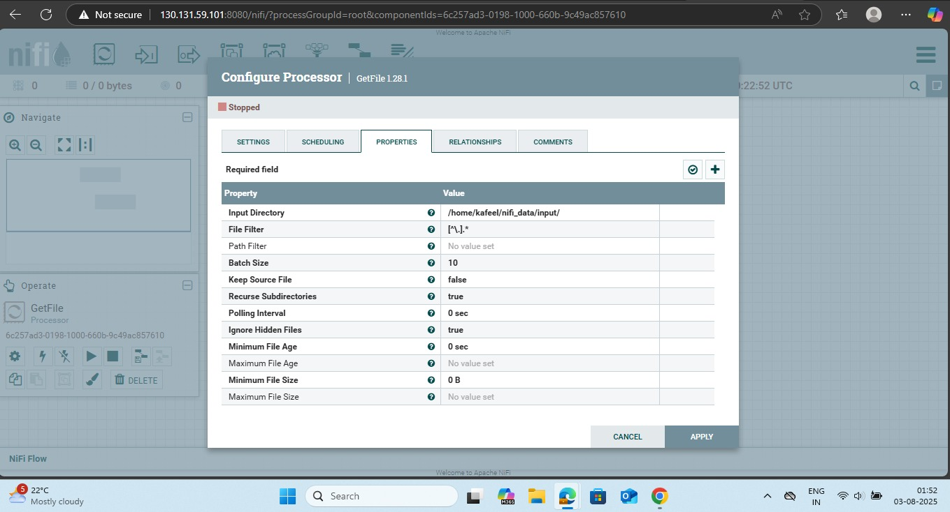

* ***Nifi Ingestor Processor (Getfile --> PublishKafka_2.0)***

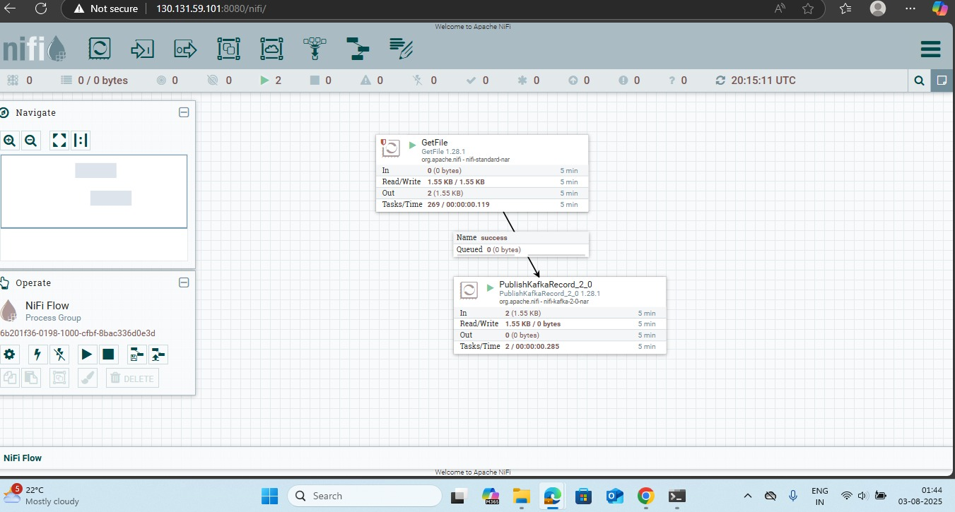

* ***Storage Account***

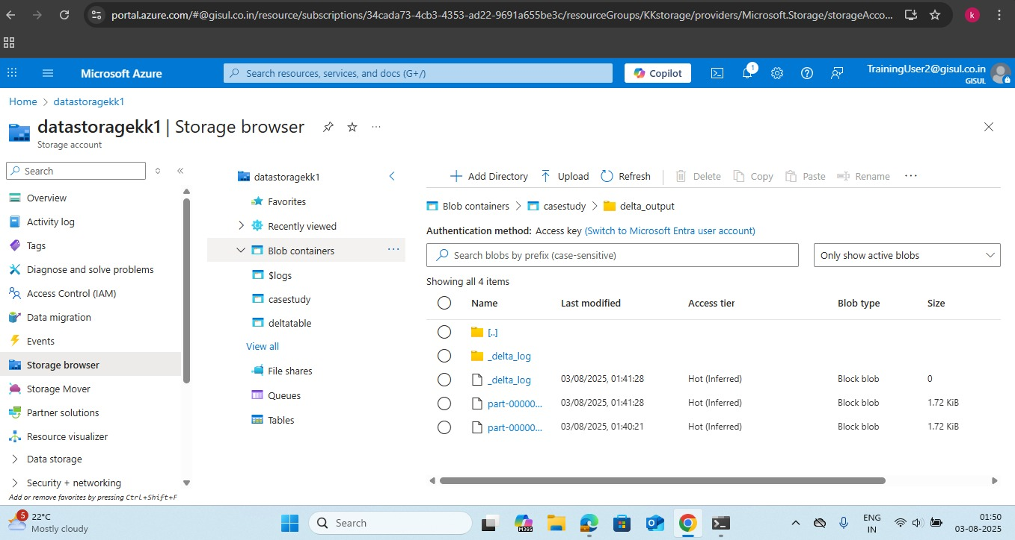

* ***Storage browser – Bronze layer***

